Validate the Complete 3-Tier Architecture
Web application is accessible through the Public Application Load Balancer.
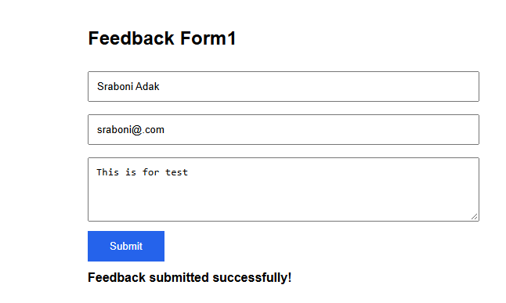
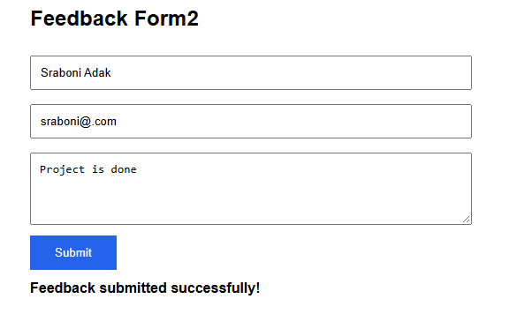
Nginx successfully forwards API requests to the Internal Load Balancer.
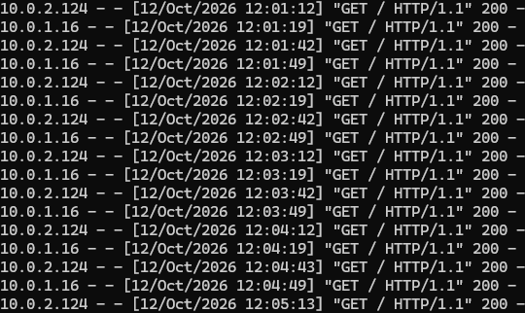
Feedback data is stored in Amazon RDS MySQL.
